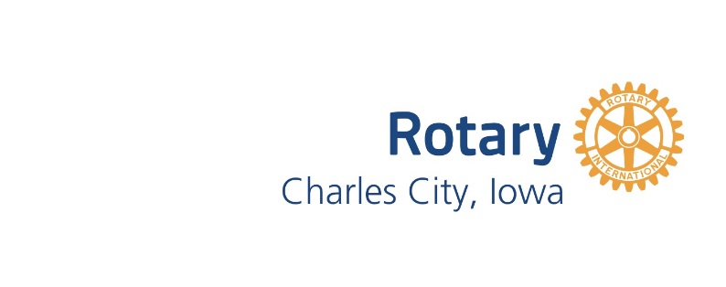
Meal Opt Out Request

Name

Please indicate which meal(s) you wish to opt out of by filling in the dates below. *

Month:______________ Month:______________ Month:______________
Date:
Date:
Date:
Date:

* Your quarterly statement will continue to include a $25 charge for the facilities cost. However, you may opt out of any or all the meals each quarter.

Please return this form to Marcie Andrews (deanandmarcie@gmail.com) no later than the following dates:
March 15
June 15
September 15
December 15

